**PUSL3190 Computing Individual Project**

**Interim Report**

Plex.lk

Supervisor: Mrs. Pavithra Subhashini

Name: Ambagahapathirage L Perera

Plymouth Index Number: 10899650

Degree Program: BSc(Hons) Software Engineering

# Table of Contents

# Chapter 01 - Introduction

## 1.1 Introduction

Sri Lanka has long been a favorite travel destination for its rich cultural heritage, stunning landscapes, and warm hospitality. While the country attracts a significant number of first-time visitors, retaining repeat tourists remains a challenge. Many tourists prefer exploring new destinations rather than revisiting places they have already been to. This project, **Plex.lk**, aims to address this issue by introducing an innovative web platform that gamifies the tourism experience, making return visits more engaging and rewarding.

Plex.lk is designed specifically for tourists who have already visited Sri Lanka at least once. By incorporating gamification elements such as "**plexes**" (points assigned to locations based on difficulty), geo-location-based verification, leaderboards, and a knowledge-sharing section, the platform encourages travelers to explore lesser-known destinations. This project leverages modern technology to provide an interactive and personalized travel experience, ultimately fostering a stronger connection between tourists and Sri Lanka’s hidden gems.

## 1.2 Problem Definition

Despite Sri Lanka's appeal as a travel destination, **only 30% of international visitors return for a second trip** (Airport Survey, 2019). This highlights a significant gap in the country's tourism sector, while Sri Lanka successfully attracts first-time tourists, it struggles to retain them. Several factors contribute to this issue:

### Limited Promotion of Lesser-Known Destinations

Popular tourist spots such as Colombo, Kandy, and Galle receive most of the attention, while many equally breathtaking locations remain undiscovered due to a lack of visibility.

### Lack of an Engaging and Personalized Experience

Tourists often feel that they have "seen it all" after their first visit, as there are no compelling reasons to return.

### Challenges in Trip Planning and Information Accessibility

Tourists face difficulties in discovering new places, accessing local insights, and navigating transportation. Language barriers and outdated information add to this challenge.

### Slow Adoption of Digital and Gamified Tourism Solutions

Unlike other travel industries that use modern technology to enhance engagement, Sri Lanka’s tourism sector lacks an interactive platform that encourages return visits through gamification.

Plex.lk aims to bridge this gap by offering an engaging, technology-driven solution that rewards travelers for their explorations, making each return visit feel like a new adventure.

## 1.3 Project Objectives

The primary objective of **Plex.lk** is to **increase the number of repeat tourists to Sri Lanka** by making travel more engaging and rewarding. This will be achieved through the following goals:

* **Encourage exploration of lesser-known locations** by gamifying the travel experience and assigning points ("plexes") based on location difficulty.
* **Enhance tourist engagement** through an interactive platform featuring leaderboards, virtual flag placements, and user-contributed travel insights.
* **Utilize geo-location-based verification** to ensure authenticity in travel achievements and reward real visits.
* **Provide an intuitive and user-friendly interface** that simplifies trip planning, allowing users to bookmark locations, access travel tips, and share their experiences.
* **Promote sustainable tourism growth** by diversifying the attractions tourists visit, leading to a more evenly distributed economic impact across Sri Lanka.

By leveraging gamification and digital technology, Plex.lk aims to transform how tourists experience Sri Lanka, making it a destination worth revisiting multiple times.

# Chapter 02 - System Analysis

## 2.1 Facts Gathering Techniques

To ensure that Plex.lk is built based on accurate insights and real user needs, various fact-gathering techniques were utilized during the initial research phase. The primary methods used are:

### Literature Review

A thorough analysis of reports from the Sri Lanka Tourism Development Authority (SLTDA) and the 2019 Airport Survey helped identify key statistics related to tourism trends and return visitor rates.

### Interviews with Industry Experts

Conversations with local tourist guides and professionals in the tourism industry provided firsthand insights into the challenges faced by returning tourists.

### Online Surveys and Questionnaires

A set of structured questions was distributed to past visitors to Sri Lanka via travel forums and social media groups to gather opinions on their experiences and reasons for not returning.

### Competitor Analysis

An evaluation of existing tourism platforms and travel apps was conducted to identify gaps in their offerings, specifically regarding gamification and engagement strategies for repeat tourists.

### Observations and Case Studies

A detailed examination of gamified travel applications in other countries helped me understand best practices for implementing point-based reward systems and interactive travel features.

These techniques ensured that Plex.lk is designed based on real challenges and unmet needs in Sri Lanka’s tourism industry.

## 2.2 Existing System

Currently, Sri Lanka’s tourism industry relies **on traditional and digital platforms** to attract and engage tourists. The existing systems fall into three main categories:

### Government Tourism Websites

Platforms such as the Sri Lanka Tourism Development Authority (SLTDA) website provide information on destinations, accommodations, and travel regulations but lack interactive engagement features.

### Travel Booking and Review Sites

Websites like TripAdvisor, Booking.com, and Google Maps allow tourists to book accommodations and read reviews, but they do not actively encourage return visits.

1. Social Media and Travel Blogs

Tourists often rely on personal blogs, YouTube travel vlogs, and Instagram posts for travel recommendations. While these provide inspiration, they do not facilitate structured exploration or engagement.

None of the existing systems gamify the experience of traveling in Sri Lanka or provide a structured incentive-based approach to encourage repeat visits.

## 2.3 Use Case Diagram

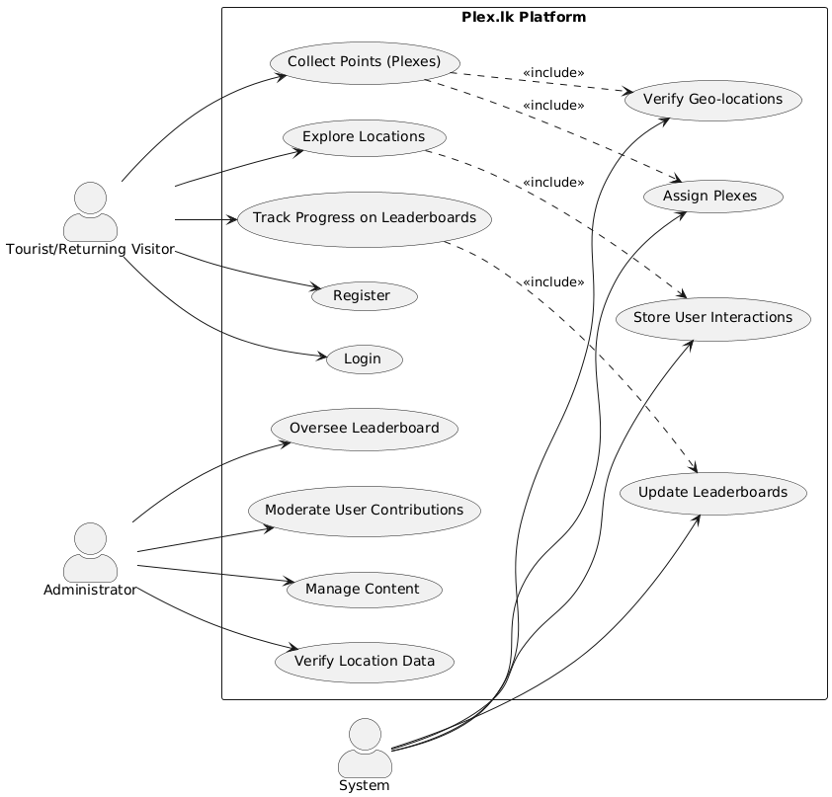

Figure 1 - Use Case Diagram

## 2.4 Drawbacks of the Existing System

The current tourism engagement system in Sri Lanka has several limitations:

### Lack of Gamification and Incentives

Existing platforms do not provide a reward system to encourage tourists to explore more locations or return for another visit.

### Limited Promotion of Lesser-Known Locations

The majority of tourism websites and services focus on popular destinations, leaving hidden gems underexplored and underpromoted.

### No Geo-Verification Mechanism

Tourists rely on self-reported visits without a system to verify whether they have truly visited a location.

### Absence of Community Engagement Features

Current platforms do not motivate travelers through competitive elements like leaderboards or travel challenges.

### Difficulties in Trip Planning

Tourists face fragmented information, making it hard to plan customized travel experiences based on their previous visits.

By addressing these drawbacks, Plex.lk introduces a gamified, interactive, and rewarding system that enhances engagement and encourages repeat tourism in Sri Lanka.

# Chapter 03 - Requirements Specification

## Functional Requirements

Functional requirements define the core functionalities and features that Plex.lk must offer to ensure a smooth and engaging experience for users. The key functional requirements include:

### User Authentication and Profiles

* Users must be able to register, log in, and manage their profiles.
* Authentication should be secure, using email verification or social login options.

### Location Discovery and Exploration

* Users can browse a list of locations with details such as difficulty level, accessibility, and historical information.
* A search and filter feature should be available to help users find specific locations.

### Gamification and Points System (Plexes)

* Each location should be assigned a difficulty level and a corresponding number of "plexes" (points).
* Users earn plexes when they visit a location and verify their visit.

### Geo-Location-Based Flag Placement

* Users can place a virtual flag at a location upon visiting.
* The system should verify the user’s geo-coordinates before awarding plexes.

### Leaderboard System

* Users should be ranked based on their total plexes.

### Knowledge Sharing (Book of Knowledge & Blogs)

* Users can contribute travel tips, historical insights, and personal experiences about locations.
* A blog section should allow users to share detailed travel stories.

### Trip Planning Features

* Users should be able to bookmark locations for future visits.
* A custom itinerary planner should be available to help organize trips.

### Admin Panel for Content Management

* Administrators should be able to add, edit, or remove locations and update site content.
* Admins should also manage leaderboards and blogs.

## Non-Functional Requirements

Non-functional requirements ensure the system is reliable, scalable, and secure.

### Performance Requirements

* The website should load within 3 seconds on a standard internet connection.
* Geo-location verification should be processed in real-time.

### Scalability

* The system should support thousands of users simultaneously without performance degradation.
* The database should efficiently handle large volumes of location and user data.

### Security Requirements

* User authentication should use encryption and secure hashing (e.g., JWT, OAuth2.0).
* Geo-location data must be protected to ensure user privacy.

### Usability Requirements

* The UI should be **responsive** and optimized for both mobile and desktop devices.
* The platform should be designed for easy navigation with minimal learning curve.

### Data Integrity and Backup

* The system should automatically back up data daily to prevent loss.
* There should be a rollback mechanism for restoring previous versions of location data.

### Availability & Reliability

* The system should have a 99.9% uptime guarantee.
* It should be hosted on Azure with failover mechanisms in place.

## 3.3 Hardware / Software Requirements

|  |  |
| --- | --- |
| **Component** | **Specification / Technology** |
| Server | Cloud-based (Azure) |
| Client Devices | Any device with a modern web browser (PC, mobile, tablet) |
| Frontend | Next.js, Tailwind CSS, ShadCN UI |
| Backend | Node.js, Express.js |
| Database | MongoDB (Atlas) |
| Geo-Location API | Google Maps API |
| Authentication | Firebase Auth / OAuth2.0 |
| Hosting | Azure Cloud Services |
| Version Control | GitHub |
| UI/UX Design | Figma |

## Networking Requirements

### Hosting and Cloud Infrastructure

* The system will be hosted on Azure Cloud Services to ensure scalability and availability.
* The database will be stored in MongoDB Atlas, providing secure and distributed storage.

### Network Bandwidth Requirements

* The platform should efficiently handle real-time location tracking requests without latency issues.

### Security and Access Control

* SSL/TLS encryption must be enabled for all data transmissions.
* API requests should be secured using OAuth2.0 and JWT authentication.

### Geo-Location Services Connectivity

* The system must maintain a stable connection with the Google Maps API for real-time location tracking and verification.
* A backup mechanism should be in place in case the primary geo-location service fails.

This section outlines the necessary technical and infrastructure requirements for Plex.lk to function efficiently.

# Chapter 04 – Feasibility Study

## Operational Feasibility

Operational feasibility assesses whether the proposed system, Plex.lk, can be effectively implemented and used in real-world conditions.

### User Adoption & Engagement

* The project targets repeat tourists, a niche audience with an existing interest in Sri Lanka.
* Gamification elements (plexes, leaderboards, and rewards) make the platform engaging, increasing the likelihood of long-term user retention.
* The geo-location-based verification system ensures authenticity, enhancing credibility and trust.

### Stakeholder Benefits

* Tourists: Gain a unique and interactive way to explore Sri Lanka, motivating them to return.
* Local Tourism Sector: Encourages visitors to explore lesser-known destinations, leading to a more evenly distributed economic impact.
* Sri Lanka Tourism Authorities & Businesses: The platform can support partnerships with hotels, tour operators, and local businesses to increase revenue.

### Ease of Use

* The Next.js and Tailwind-based UI ensures an intuitive experience, making navigation seamless for users.
* Mobile-friendliness allows travelers to access features on the go.
* A bookmarking and itinerary planning feature further simplifies trip organization.

### Scalability

* The platform is cloud-hosted on Azure, ensuring it can handle increasing traffic over time.
* MongoDB Atlas enables flexible data management, supporting growth without major performance issues.

Thus, **Plex.lk** is operationally feasible as it meets user needs, aligns with tourism industry goals, and is easy to adopt and scale.

## Technical Feasibility

Technical feasibility evaluates whether the necessary technology, skills, and resources are available to develop and deploy Plex.lk successfully.

### Technology Readiness

* The project will use modern, widely adopted technologies such as Next.js (frontend), Node.js (backend), MongoDB (database), and Google Maps API (geo-location verification).
* Hosting on Azure Cloud Services ensures scalability and high availability (99.9% uptime guarantee).
* The Google Maps API is a reliable solution for location tracking and verification.

### Development & Expertise

* Frontend & Backend Development: Next.js, Tailwind CSS, Node.js, and Express.js are widely supported with extensive documentation and community resources.
* Database Management: MongoDB Atlas provides secure and scalable data storage, ensuring seamless integration with the backend.
* Security & Authentication: OAuth 2.0 and Firebase Authentication will be implemented to ensure secure user logins.
* Gamification Logic: Implementing a point-based system (plexes) and leaderboard ranking is technically achievable using database queries and API interactions.

### Potential Challenges & Mitigation Strategies

|  |  |
| --- | --- |
| **Challenge** | **Solution** |
| Ensuring accurate geo-location verification | Use Google Maps API with real-time GPS tracking |
| Handling large amounts of user-generated data | Optimize MongoDB indexing for fast queries |
| Managing user privacy and security | Implement data encryption, secure authentication, and GDPR compliance |

## 4.3 Outline Budget

The financial feasibility of Plex.lk is based on a cost-effective approach, leveraging free open-source tools for development while only investing in essential services.

### Estimated Budget Breakdown

|  |  |  |
| --- | --- | --- |
| **Category** | **Item** | **Estimated Cost (LKR)** |
| Domain & Hosting | .lk Domain Registration (LK Domain Registry) | 10,000 LKR (Annual) |
|  | Azure Hosting (Free under MLSA) | 0 LKR |
| Development & Technology | Google Maps API (Geo-location services) | Free tier |
|  | Next.js, Tailwind CSS, ShadCN (Frontend) | Free (Open-source) |
|  | Node.js, Express.js (Backend) | Free (Open-source) |
|  | MongoDB Atlas (Database) | Free (Starter Tier) |
| UI/UX & Design | Figma (Prototyping & Wireframing) | Free |
| Security & Authentication | Firebase Auth / OAuth 2.0 | Free (Basic Plan) |
| Testing & Deployment | Postman (API Testing) | Free |
| Marketing & Promotions | Initial social media ads & outreach | 5,000 LKR |
| **Total Estimated Cost** |  | **~15,000 LKR (Annual)** |

### Cost Justification

* Majority of tools are free (open-source or free-tier plans).
* Hosting on Azure (MLSA) ensures zero cost for cloud infrastructure.
* Low maintenance costs make the project sustainable for long-term growth.

### Potential Funding Sources

* **Personal investment** – Initial development costs are minimal.
* **Tourism industry partnerships** – Potential funding from Sri Lanka Tourism Board or private tourism companies.
* **Advertisements & Premium Features (Future Monetization)** – The platform can introduce sponsored listings and paid travel guides for revenue generation.

Since the financial requirements are minimal and manageable, Plex.lk is financially feasible with minimal investment.

The feasibility study confirms that Plex.lk is operationally, technically, and financially viable. The platform leverages modern, scalable technologies, has low-cost requirements, and provides a high-value solution for increasing repeat tourism in Sri Lanka.

# Chapter 05 - System Architecture

## 5.1 Class Diagram

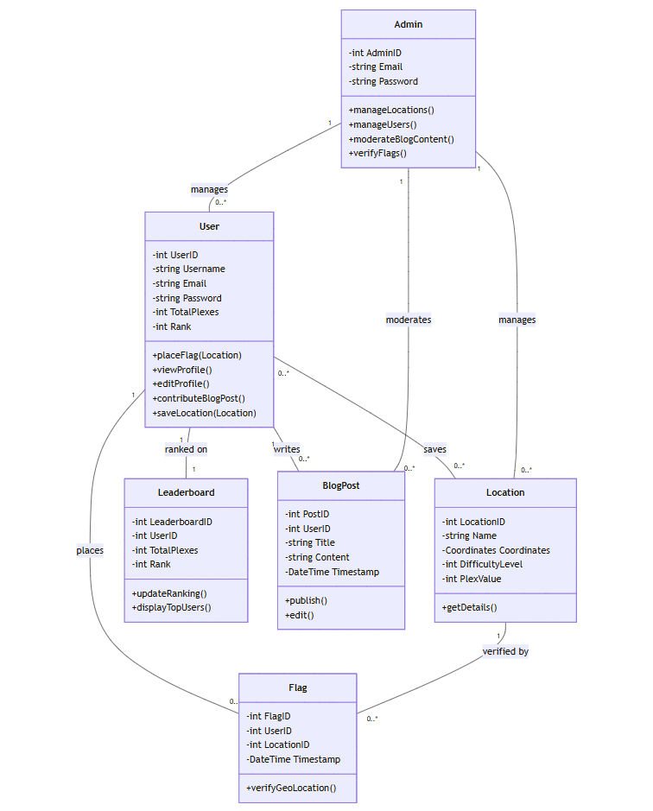

Figure 2 - Class Diagram

## ER Diagram

Figure 3 - ER Diagram

## 5.3 High Level Architectural Diagram

Figure 4 - High Level Architectural Diagram

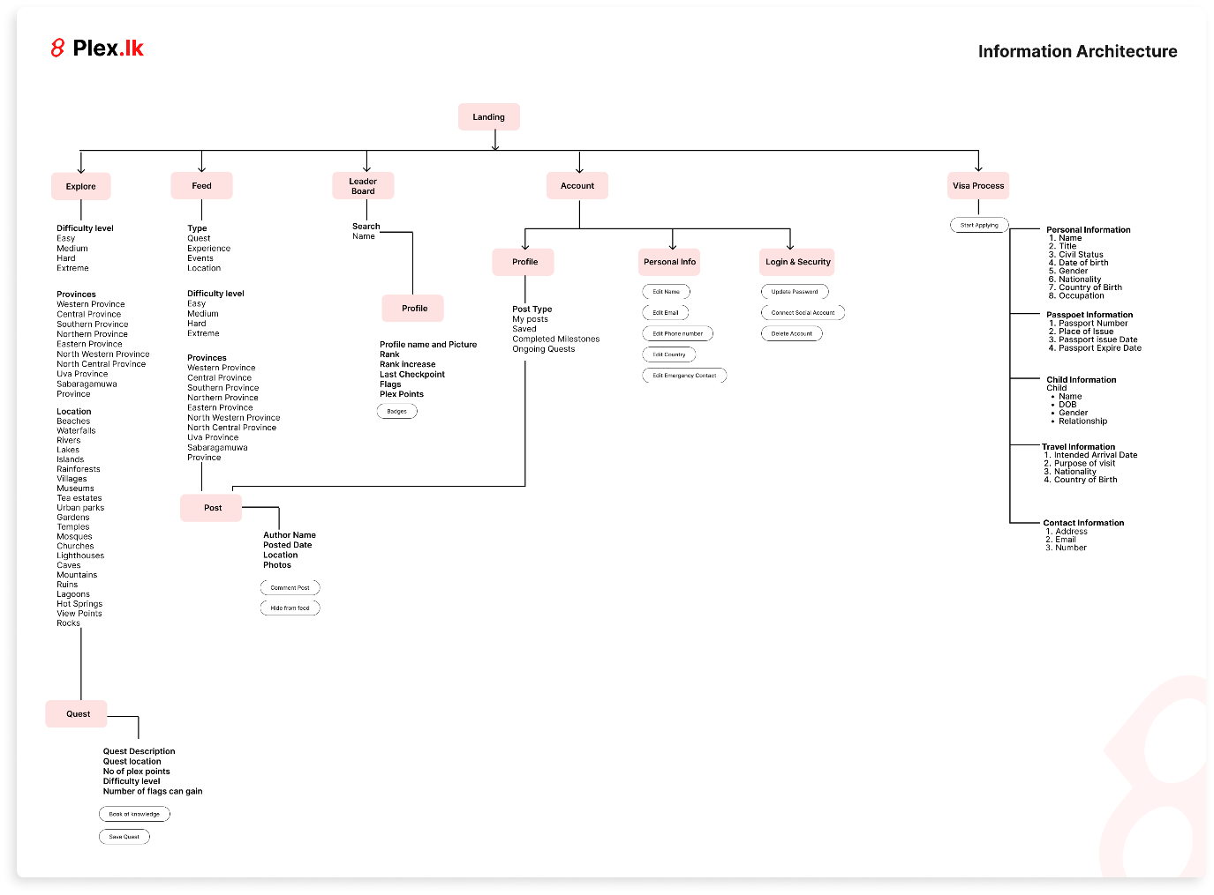

One Drive Link to the High Level Architectural Diagram:

[High Level Architectural Diagram – 10899650.pdf](https://liveplymouthac-my.sharepoint.com/:i:/g/personal/10899650_students_plymouth_ac_uk/ERqpQggWY-NLi7O40M6wb3AB6WHu2gPMsDU_pPvnvAKZ7A?e=K4Wtb3)

## 5.4 Networking Diagram

Figure 5 - Networking Diagram

This chapter provides an architectural overview of Plex.lk, covering object-oriented structure (Class Diagram), database relationships (ER Diagram), and network communication (Networking Diagram). These components define how the system will function and ensure seamless user interaction.

# Chapter 06 – Initial Project Plan

One Drive Link to the Gantt Chart - [Gantt Chart - 10899650.pdf](https://liveplymouthac-my.sharepoint.com/:b:/g/personal/10899650_students_plymouth_ac_uk/EQ8ztIqPPo9LpL1r4jgy8VgB8cnam7ZvFTijXwVnpO0ZeA?e=TqgXyQ)

# Chapter 07 - Risk Analysis

## Technical Risks

### Integration challenges between frontend (NextJS) and backend (NodeJS).

* **Likelihood:** Medium
* **Impact:** High - Could cause delays in feature delivery and affect overall functionality.
* **Mitigation Strategy:**
  + Conduct regular integration tests during development phases.
  + Use Postman or similar tools to validate API functionality early.
  + Maintain clear API documentation to reduce confusion during integration.

### Geo-location services may fail in remote or offline scenarios.

* **Likelihood:** Medium
* **Impact:** High - Could disrupt the flagship feature of the platform.
* **Mitigation Strategy:**
  + Implement a fallback mechanism, such as allowing users to upload images or other verification data.
  + Test geo-location APIs in both urban and rural environments to optimize reliability.

## Resource Risks

### Limited availability of developers with expertise in NextJS and NodeJS.

* **Likelihood:** Low
* **Impact:** Medium - May slow down development if additional help is needed.
* **Mitigation Strategy:**
  + Allocate time for upskilling if necessary.
  + Use detailed documentation and collaborative tools like Git to onboard additional resources quickly.

### Insufficient access to testing environments.

* **Likelihood:** Medium
* **Impact:** Medium - Could delay the testing phase and overall delivery timeline.
* **Mitigation Strategy:**
  + Leverage Azure sandbox environments for testing.
  + Establish a contingency budget to acquire additional testing resources if required.

## Time Risks

### Delays in UI/UX design approval or iterative feedback loops.

* **Likelihood:** Medium
* **Impact:** High - Could push back subsequent phases of development.
* **Mitigation Strategy:**
  + Set clear deadlines for feedback from stakeholders.
  + Schedule iterative reviews to ensure continuous alignment with requirements.

### Underestimation of time required for implementing complex features.

* **Likelihood:** Medium
* **Impact:** High - May compress time for testing or final deployment.
* **Mitigation Strategy:**
  + Break down complex tasks into smaller milestones.
  + Regularly review progress and adjust timelines as needed.

## Budget Risks

### Unexpected costs for third-party services like geo-location APIs or additional cloud resources.

* **Likelihood:** Medium
* **Impact:** High - Could exceed allocated budget and impact project viability.
* **Mitigation Strategy:**
  + Use free or trial versions during development.
  + Allocate a contingency budget for unforeseen expenses.

## User Adoption Risks

### Lack of user interest or engagement with the platform.

* **Likelihood:** Low
* **Impact:** High - This may lead to failure in achieving project objectives.
* **Mitigation Strategy:**
  + Conduct user research to align platform features with user preferences.
  + Market the platform effectively through targeted promotions and partnerships.

## Operational Risks

### Poor performance under high user loads, particularly during peak times.

* **Likelihood:** Medium
* **Impact:** High - Could result in negative user experience and loss of engagement.
* **Mitigation Strategy:**
  + Perform load testing during development.
  + Optimize backend and database queries to handle scale.
  + Use Azure’s scalability features to manage traffic dynamically.

By identifying these risks early and implementing robust mitigation strategies, this project aims to minimize disruptions and ensure successful delivery within the defined scope and timeline.

# Chapter 08 – Additional Sections

## Stakeholder Analysis